**EE324 Control Systems Lab**

Problem sheet 4

Tarun Sai Goddu | 190070024

**Question 1**

**1.a** The three blocks are in series, so simply a product of three transfer functions leads to equivalent transfer function along forward path. Using standard equation for feedback we get the transfer function of the system

G(s) = s + 5 + a/s + 11s + 30

Scilab Code for the same:

s = poly(0, 's');

S_1 = 1/(s^2);

S_2 = (50*s)/(s^2+s+100);

S_3 = s-2;

G = S_1*S_2*S_3

T = G/(1+G);

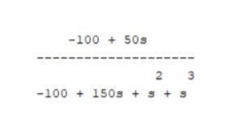

Figure 1: Input-Output Transfer Function obtained for System A

**1.b** We have the system with transfer function:

Upon simplifiying the block diagram and writing the equations we get:

sC(s) = (R(s) - 2sC(s)) /(s^2 + 1 /s )

C(s) (2s^3 + s + 2) = R( s^2+ 1 /s)

Scilab Code for the same:

s = poly(0, 's');

S_1 = s^2 + (1/s);

S_2 = 2*s^3 + s + 2;

T = S_1/S_2;

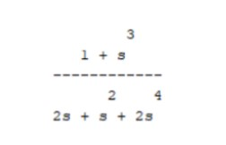

Figure 2: Input-Output Transfer Function for Part b

**1.c** Upon simplifying the block diagram and writing the equations we get:

2s(R(s) - C(s)) - 5C(s) + (3s^2 / (s + 1)(R (s) - C (s)) = (s + 1) C (s)

which finally leads to:

C(s) (3s + 6 + (3s^ 2/ (s + 1) = R(s) (3s ^2/ (s + 1) + 2s)

Scilab Code for the same:

s = poly(0, 's');

S_1 = 2*s + ((3*s^2)/(s+1));

S_2 = ((3*s^2)/(s+1)) + 6 + 3*s;

T = S_1/S_2;

Using Scilab, we obtain:

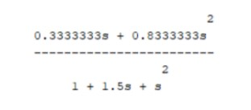

**Question 2**

**2** The transfer of the system is given by:

H(s, K) = KG (s)/ 1 + KG (s)

where, G(s) = 10 /s(s + 2)(s + 4)

**2a**

For K = 5, we obtain the closed-loop transfer function as: (K value can be changed as required)

Scilab Code for the same:

s = poly(0, 's');

G = 10/(s*(s+2)*(s+4));

K = 5;

C_tf = (G*K)/(1+(G*K));

C_tf = syslin('c',C_tf);

disp(C_tf);

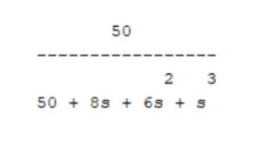

**2b**

For plotting the loccii of the closed-loop poles we use evans() function from Scilab, with maximum gain value (K) as 100. The following plot is obtained:

Scilab Code:

s = poly(0, 's');

G = 10/(s*(s+2)*(s+4));

G = syslin('c',G);

evans(G, 100);

sgrid('red');

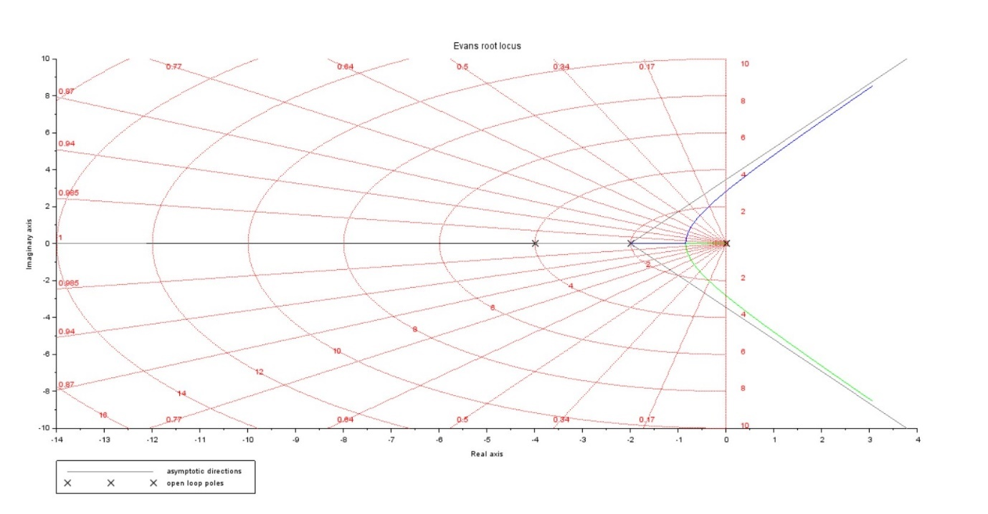

Figure 3: Loci of Closed-loop poles

**2c**

The code from part b was used here as well, so we obtain that the value of K < 4.8 are stable, as all poles in LHP. The plot with the critical point marked is shown below:

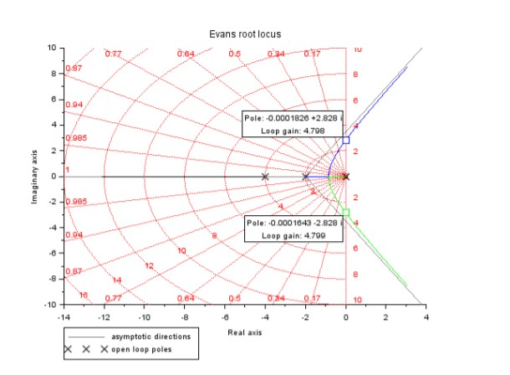

Figure 4: Critical points marked

**2d**

To confirm our answer, we display the number of sign changes for Kc - 0.1, Kc , Kc + 0.1. As expected, we see no sign change in H(s, K - 1 and a sign change in and . The routh tables c ) H(s, Kc ) H(s, Kc + 0.1) obtained for each of them are shown below:

Scilab Code:

s = poly(0, 's');

G = 10/(s*(s+2)*(s+4));

K = 4.8;

Tf = (K*G)/(1+K*G);

[r,num] = routh_t(Tf.den);

disp(num);

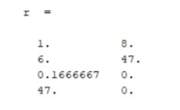

Figure 5: Routh Table for Kc – 0.1

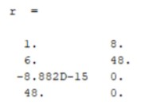

Figure 6: Routh Table for Kc

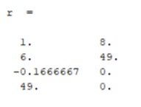

Figure 7: Routh Table for Kc+0.1

**Question 3**

**3a** We have the system with transfer function:

P(s) = s^5+ 3s^4 + 5s^3 + 4s^2 + s + 3

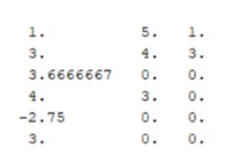

Figure 8: Routh Table

**3b**

P(s) = s^5 + 6s^3 + 5s^2 + 8s + 20

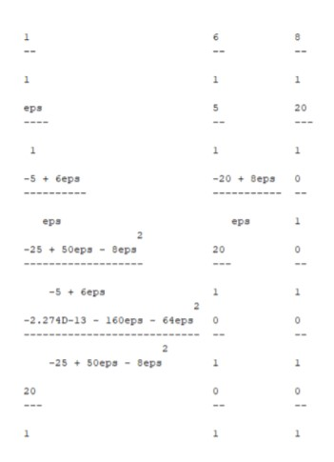

Figure 9: Routh Table

**3c**

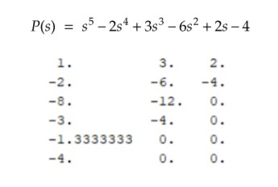

**3d**

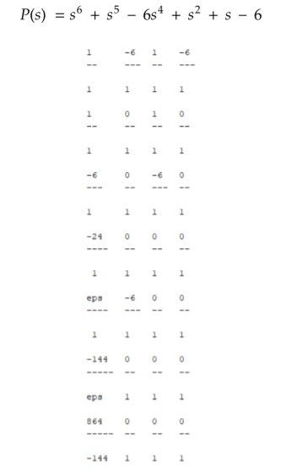

Figure 10: Routh Table

**Scilab Code:**

*// Part a*

s = poly(0, 's');

G = s^5 + 3*s^4 + 5*s^3 + 4*s^2 + s + 3;

[r,num] = routh_t(G);

disp(r);

*//Part b*

clear;

s = poly(0, 's');

G = s^5 + 6*s^3 + 5*s^2 + 8*s + 20;

[r,num] = routh_t(G); *// r is the routh table*

disp(r); *// num is the number of sign changes*

*//Part c*

clear;

s = poly(0, 's');

G = s^5 - 2*s^4 + 3*s^3 - 6*s^2 + 2*s - 4;

[r,num] = routh_t(G); *// r is the routh table*

disp(r); *// num is the number of sign changes*

*//Part d*

clear;

s = poly(0, 's');

G = s^6 + s^5 - 6*s^4 + s^2 + s - 6;

[r,num] = routh_t(G); *// r is the routh table*

disp(r); *// num is the number of sign changes*

**Question 4**

**a)**

Construct a degree 6 polynomial whose R-H table has its entire row corresponding to s to be zero:

|  |  |  |  |  |
| --- | --- | --- | --- | --- |
| S^6 | 1 | 4 | 7 | 4 |
| S^5 | 2 | 6 | 8 | 0 |
| S^4 | 1 | 3 | 4 | 0 |
| S^3 | 0 | 0 | 0 | 0 |

P(s) = s^6+2s^5+4s^4+6s^3+7s^2+8s+4

**b)**

Repeat Part (a) with a polynomial of degree 8 and having the entire row corresponding to s to be zero.

|  |  |  |  |  |  |
| --- | --- | --- | --- | --- | --- |
| S^8 | 1 | 7 | 17 | 19 | 4 |
| S^7 | 1 | 6 | 13 | 12 | 0 |
| S^6 | 1 | 4 | 7 | 4 | 0 |
| S^5 | 2 | 6 | 8 | 0 | 0 |
| S^4 | 1 | 3 | 4 | 0 | 0 |
| S^3 | 0 | 0 | 0 | 0 | 0 |

P(s) = s^8+s^7+7s^6+6s^5+17s^4+13s^3+19s^2+12s+4

**c)**

Construct a degree 6 polynomial whose R-H table has the first entry in its row corresponding to s^3 to be zero.

|  |  |  |  |  |
| --- | --- | --- | --- | --- |
| S^6 | 1 | 4 | 15/2 | 4 |
| S^5 | 2 | 6 | 9 | 0 |
| S^4 | 1 | 3 | 4 | 0 |
| S^3 | 0 | 1 | 0 | 0 |